PROJECT

ID

**BUS TICKET BOOKING ONLINE**

MEMBERS:

Subject: Software Engineering

Lecturer: Tal Tongsreng

NAME

TENG PHOUPHANIT

YANN KIMHUOY

YEN OUDOM

e20181125

e20181260

e20181269

GROUP: C3

Contents

# **OUR UI DESIGN (FIGMA)**

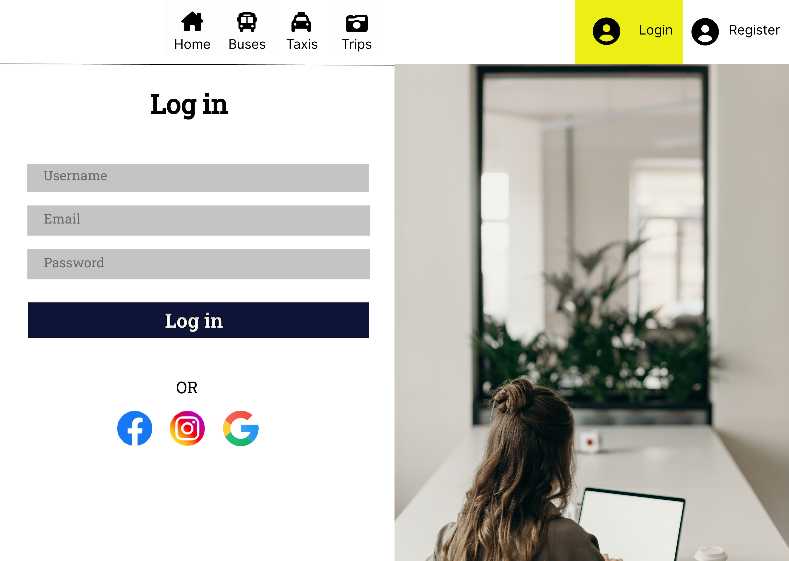

# **Login Page**

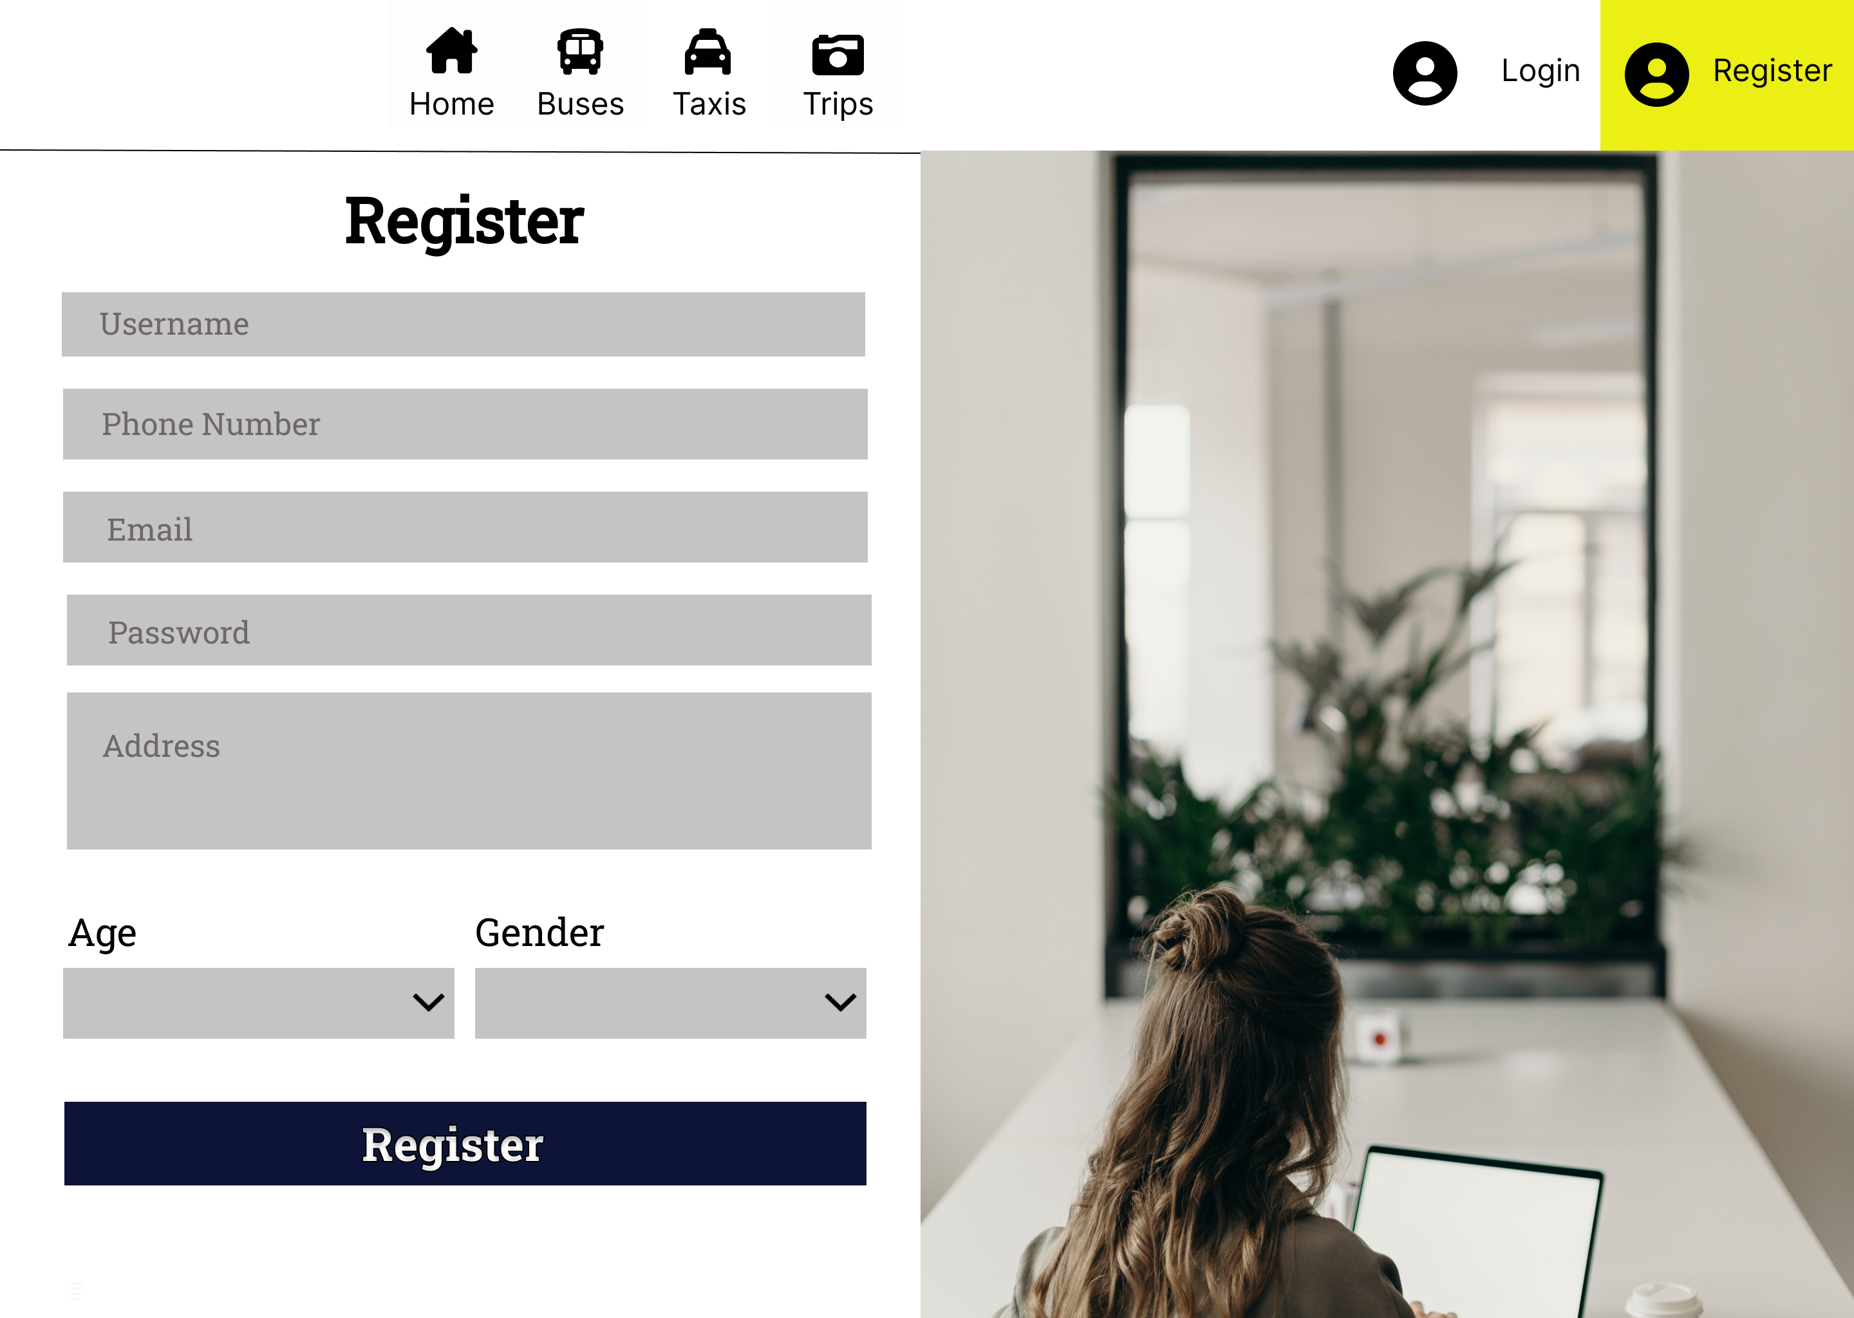

# **Register Page**

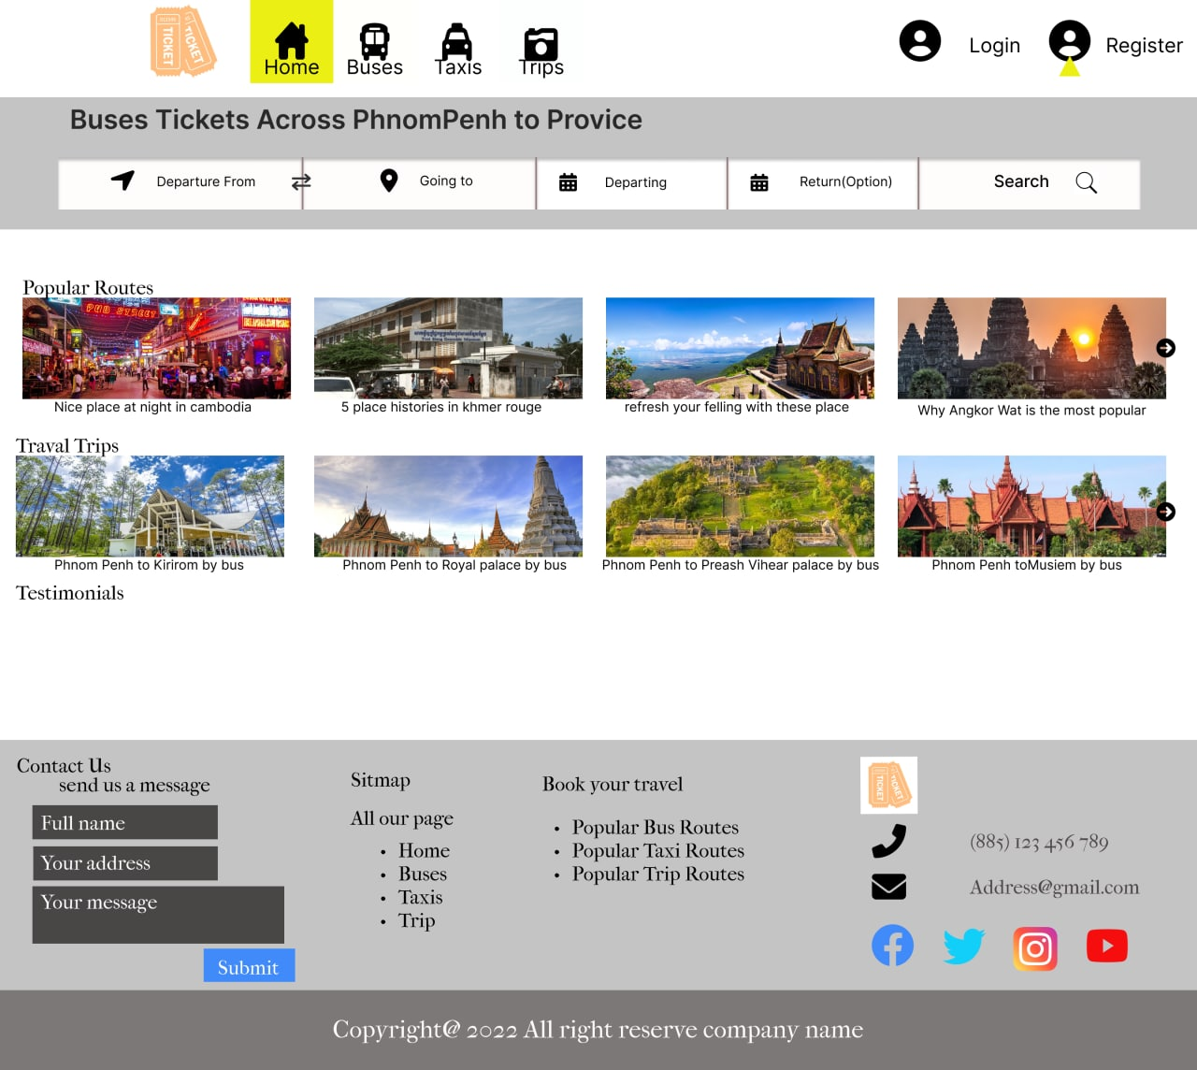

# **Home Page**

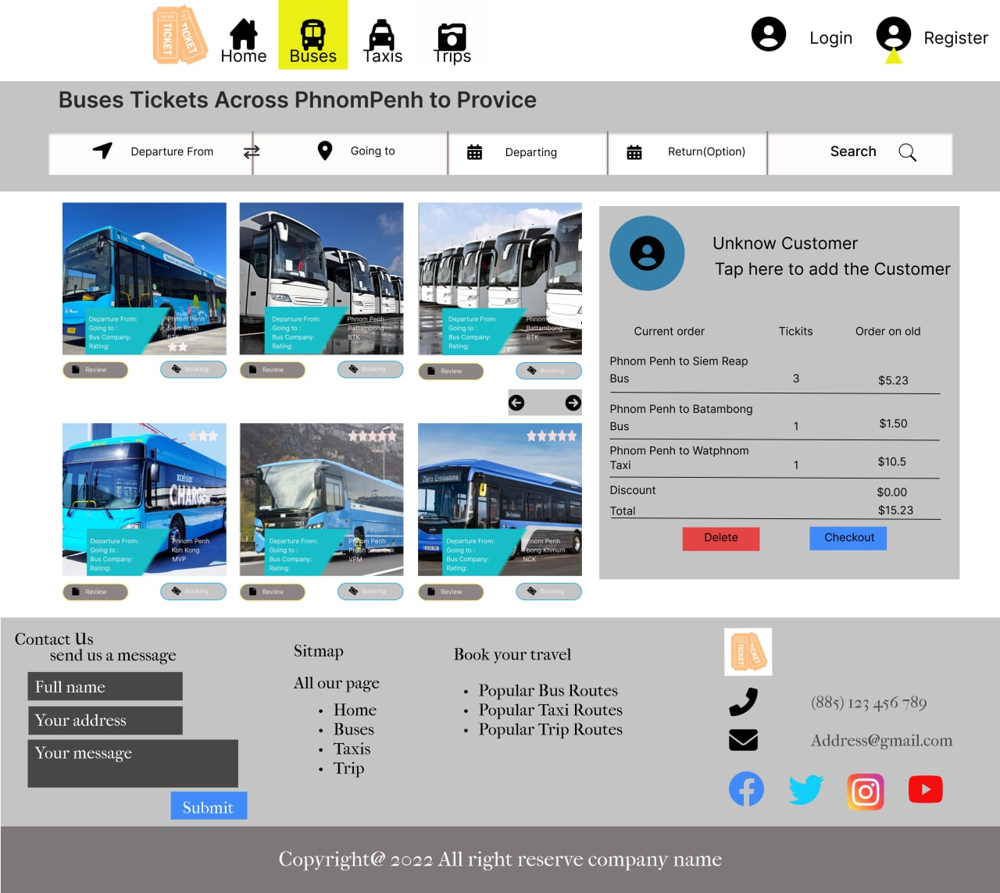

# **Bus Page**

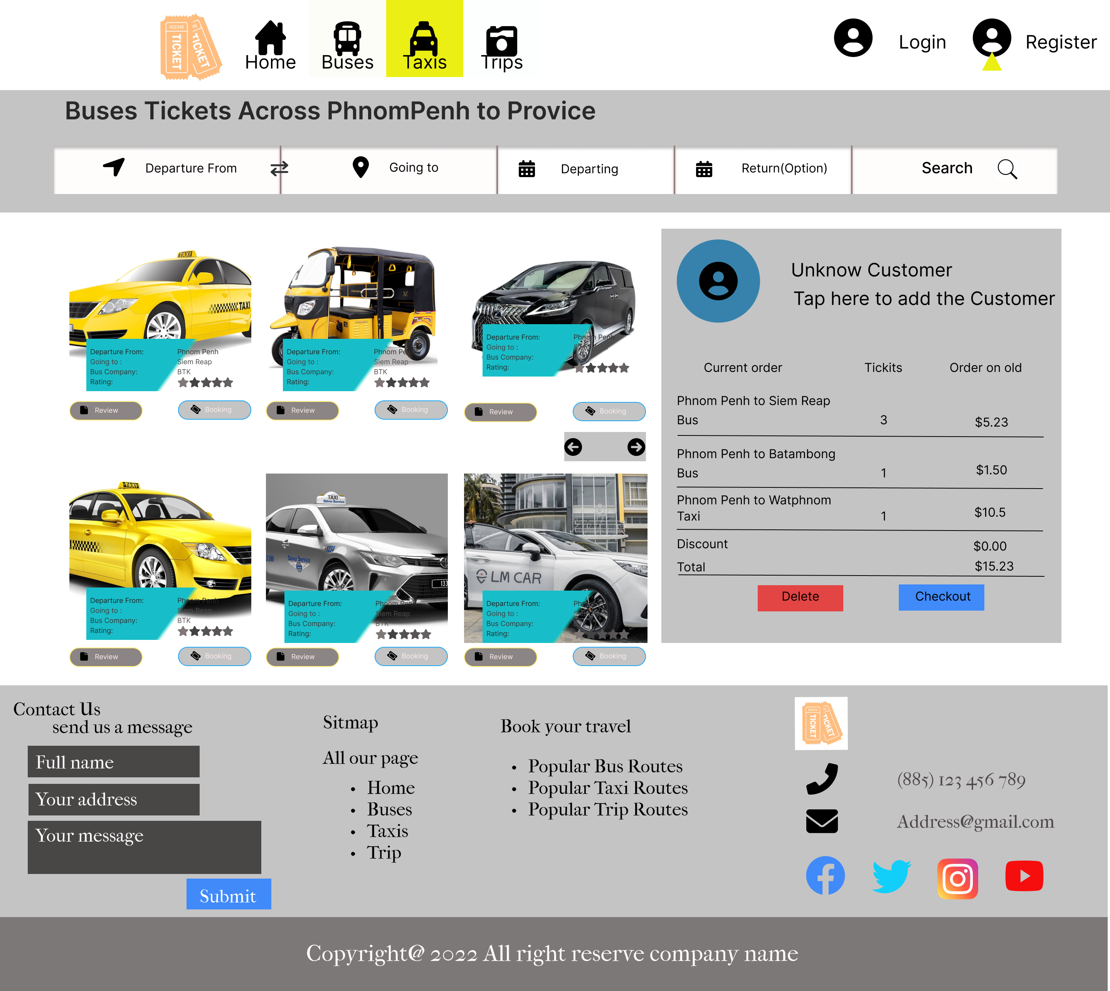

# **Taxi Page**

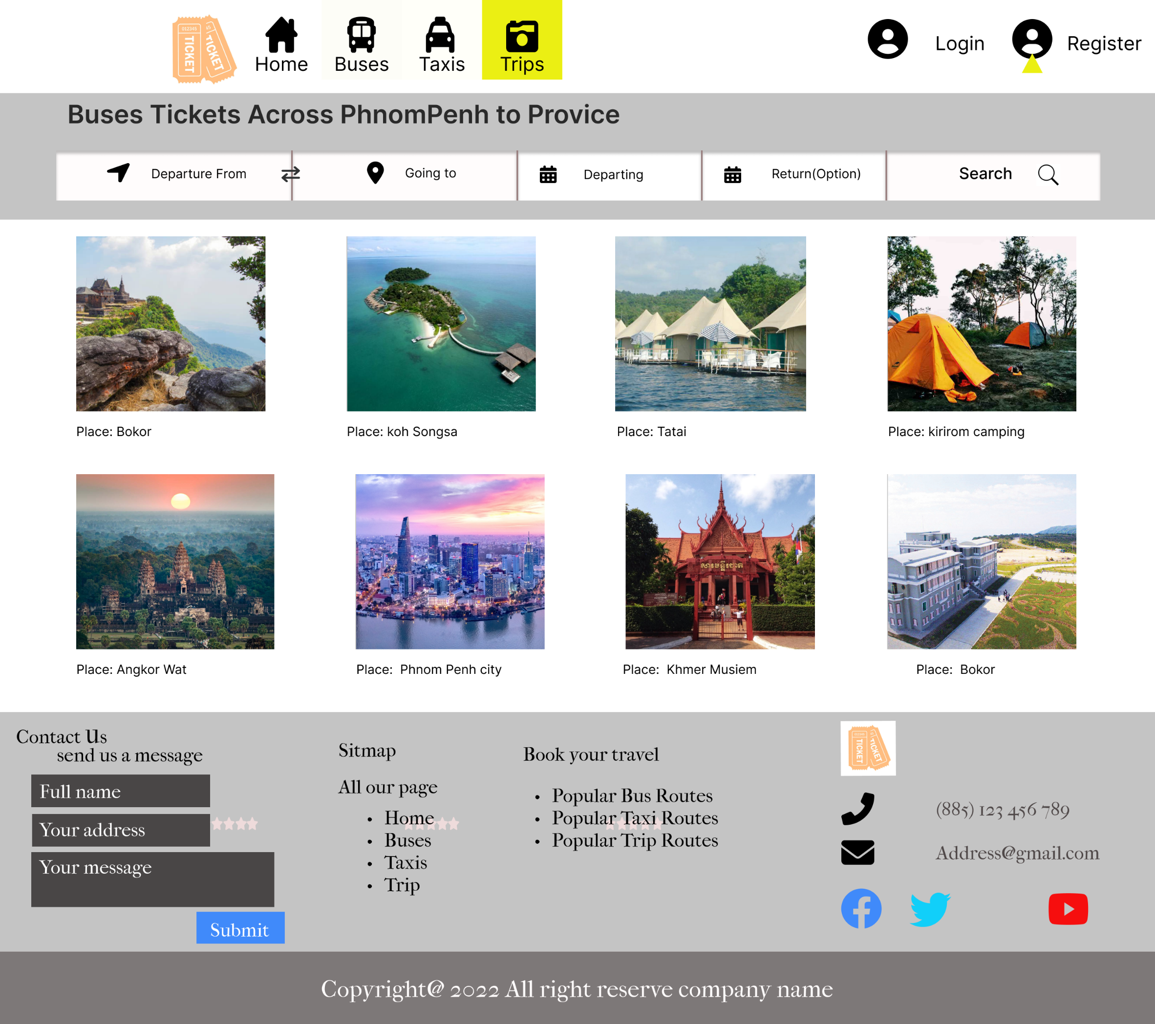

# **Trip Page**

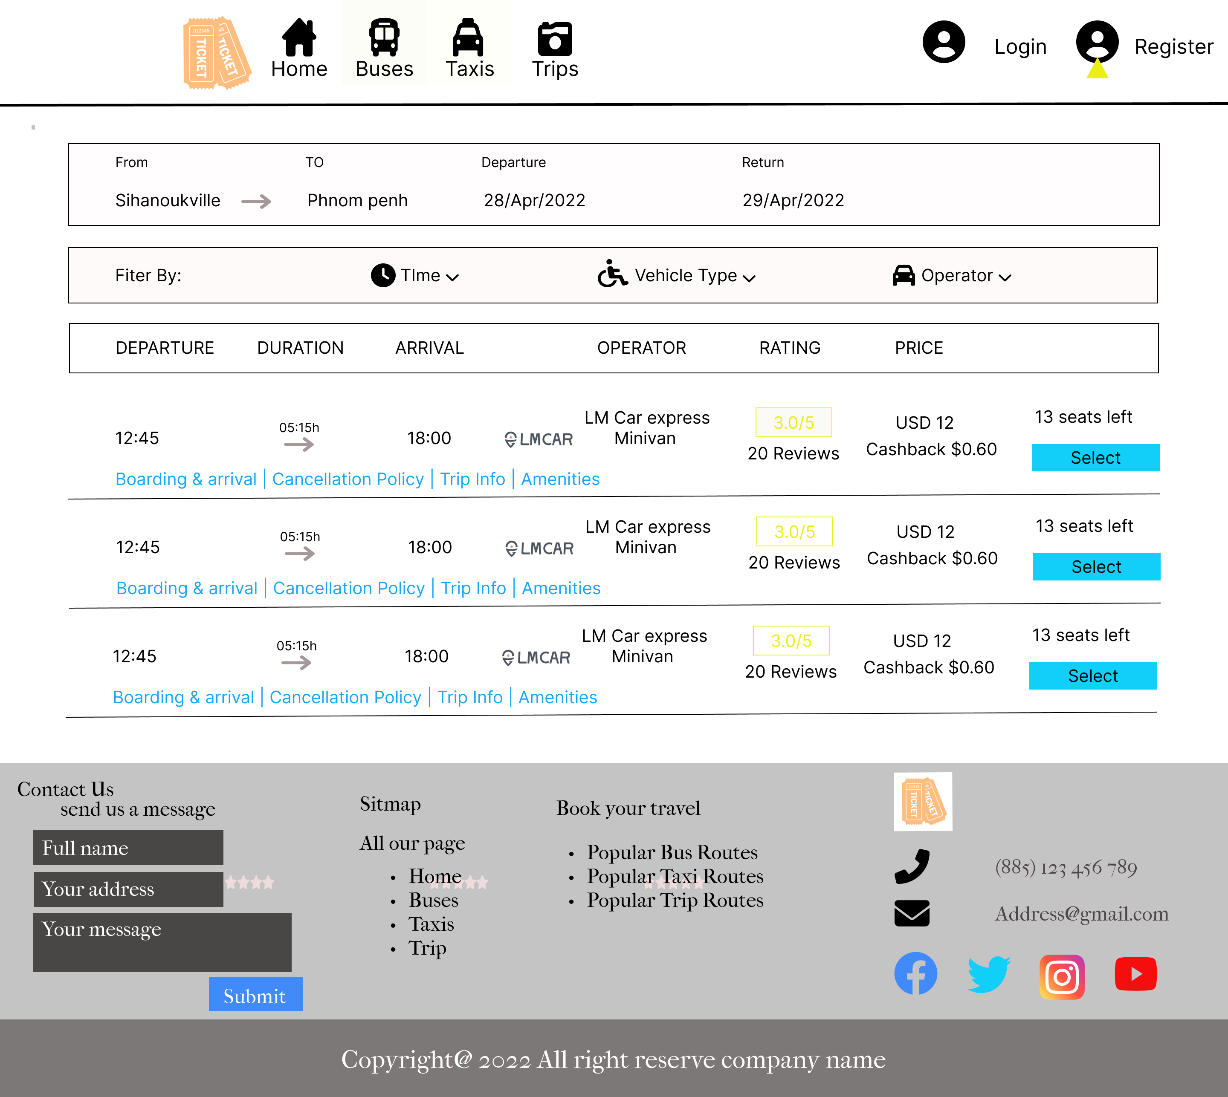

# **Selection**

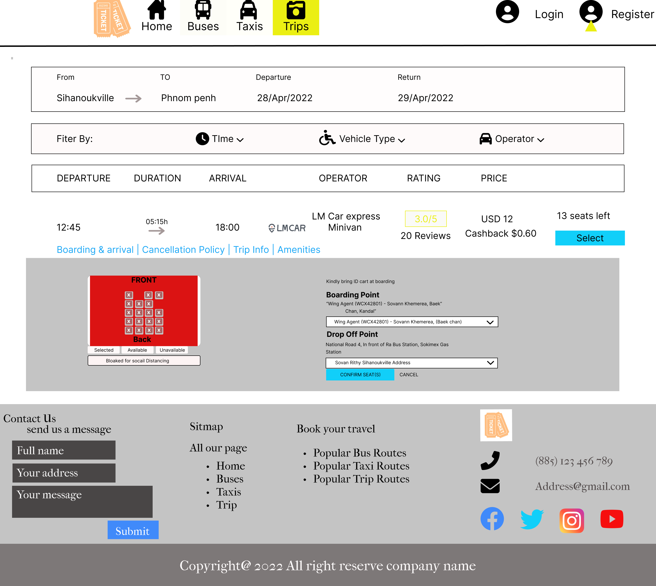

# **Seat Selection**

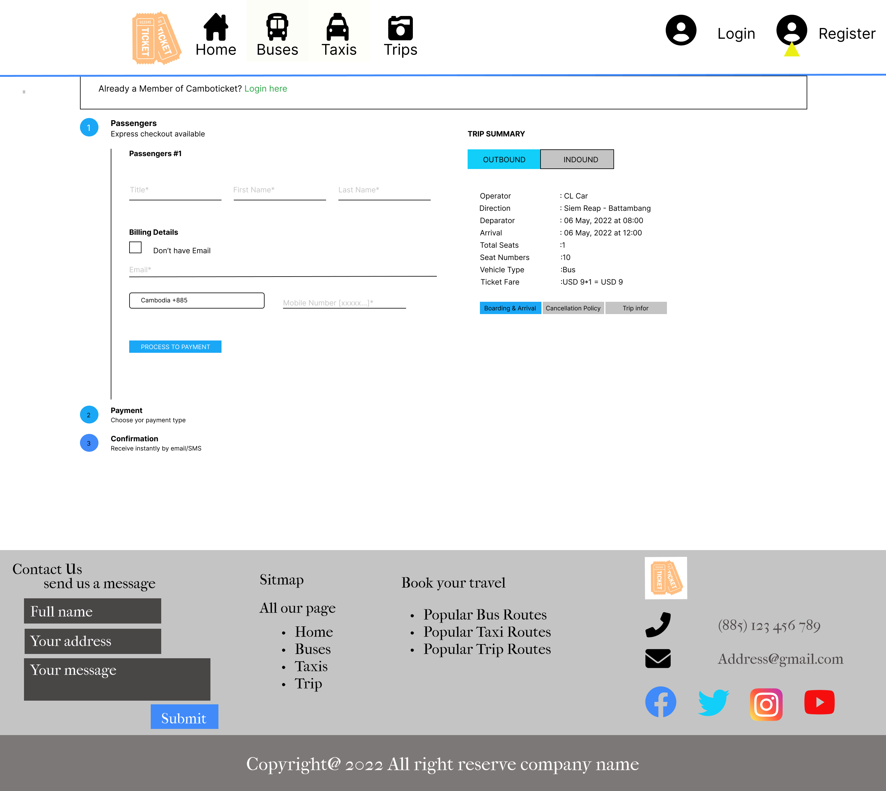

# **Form Filling for booking**

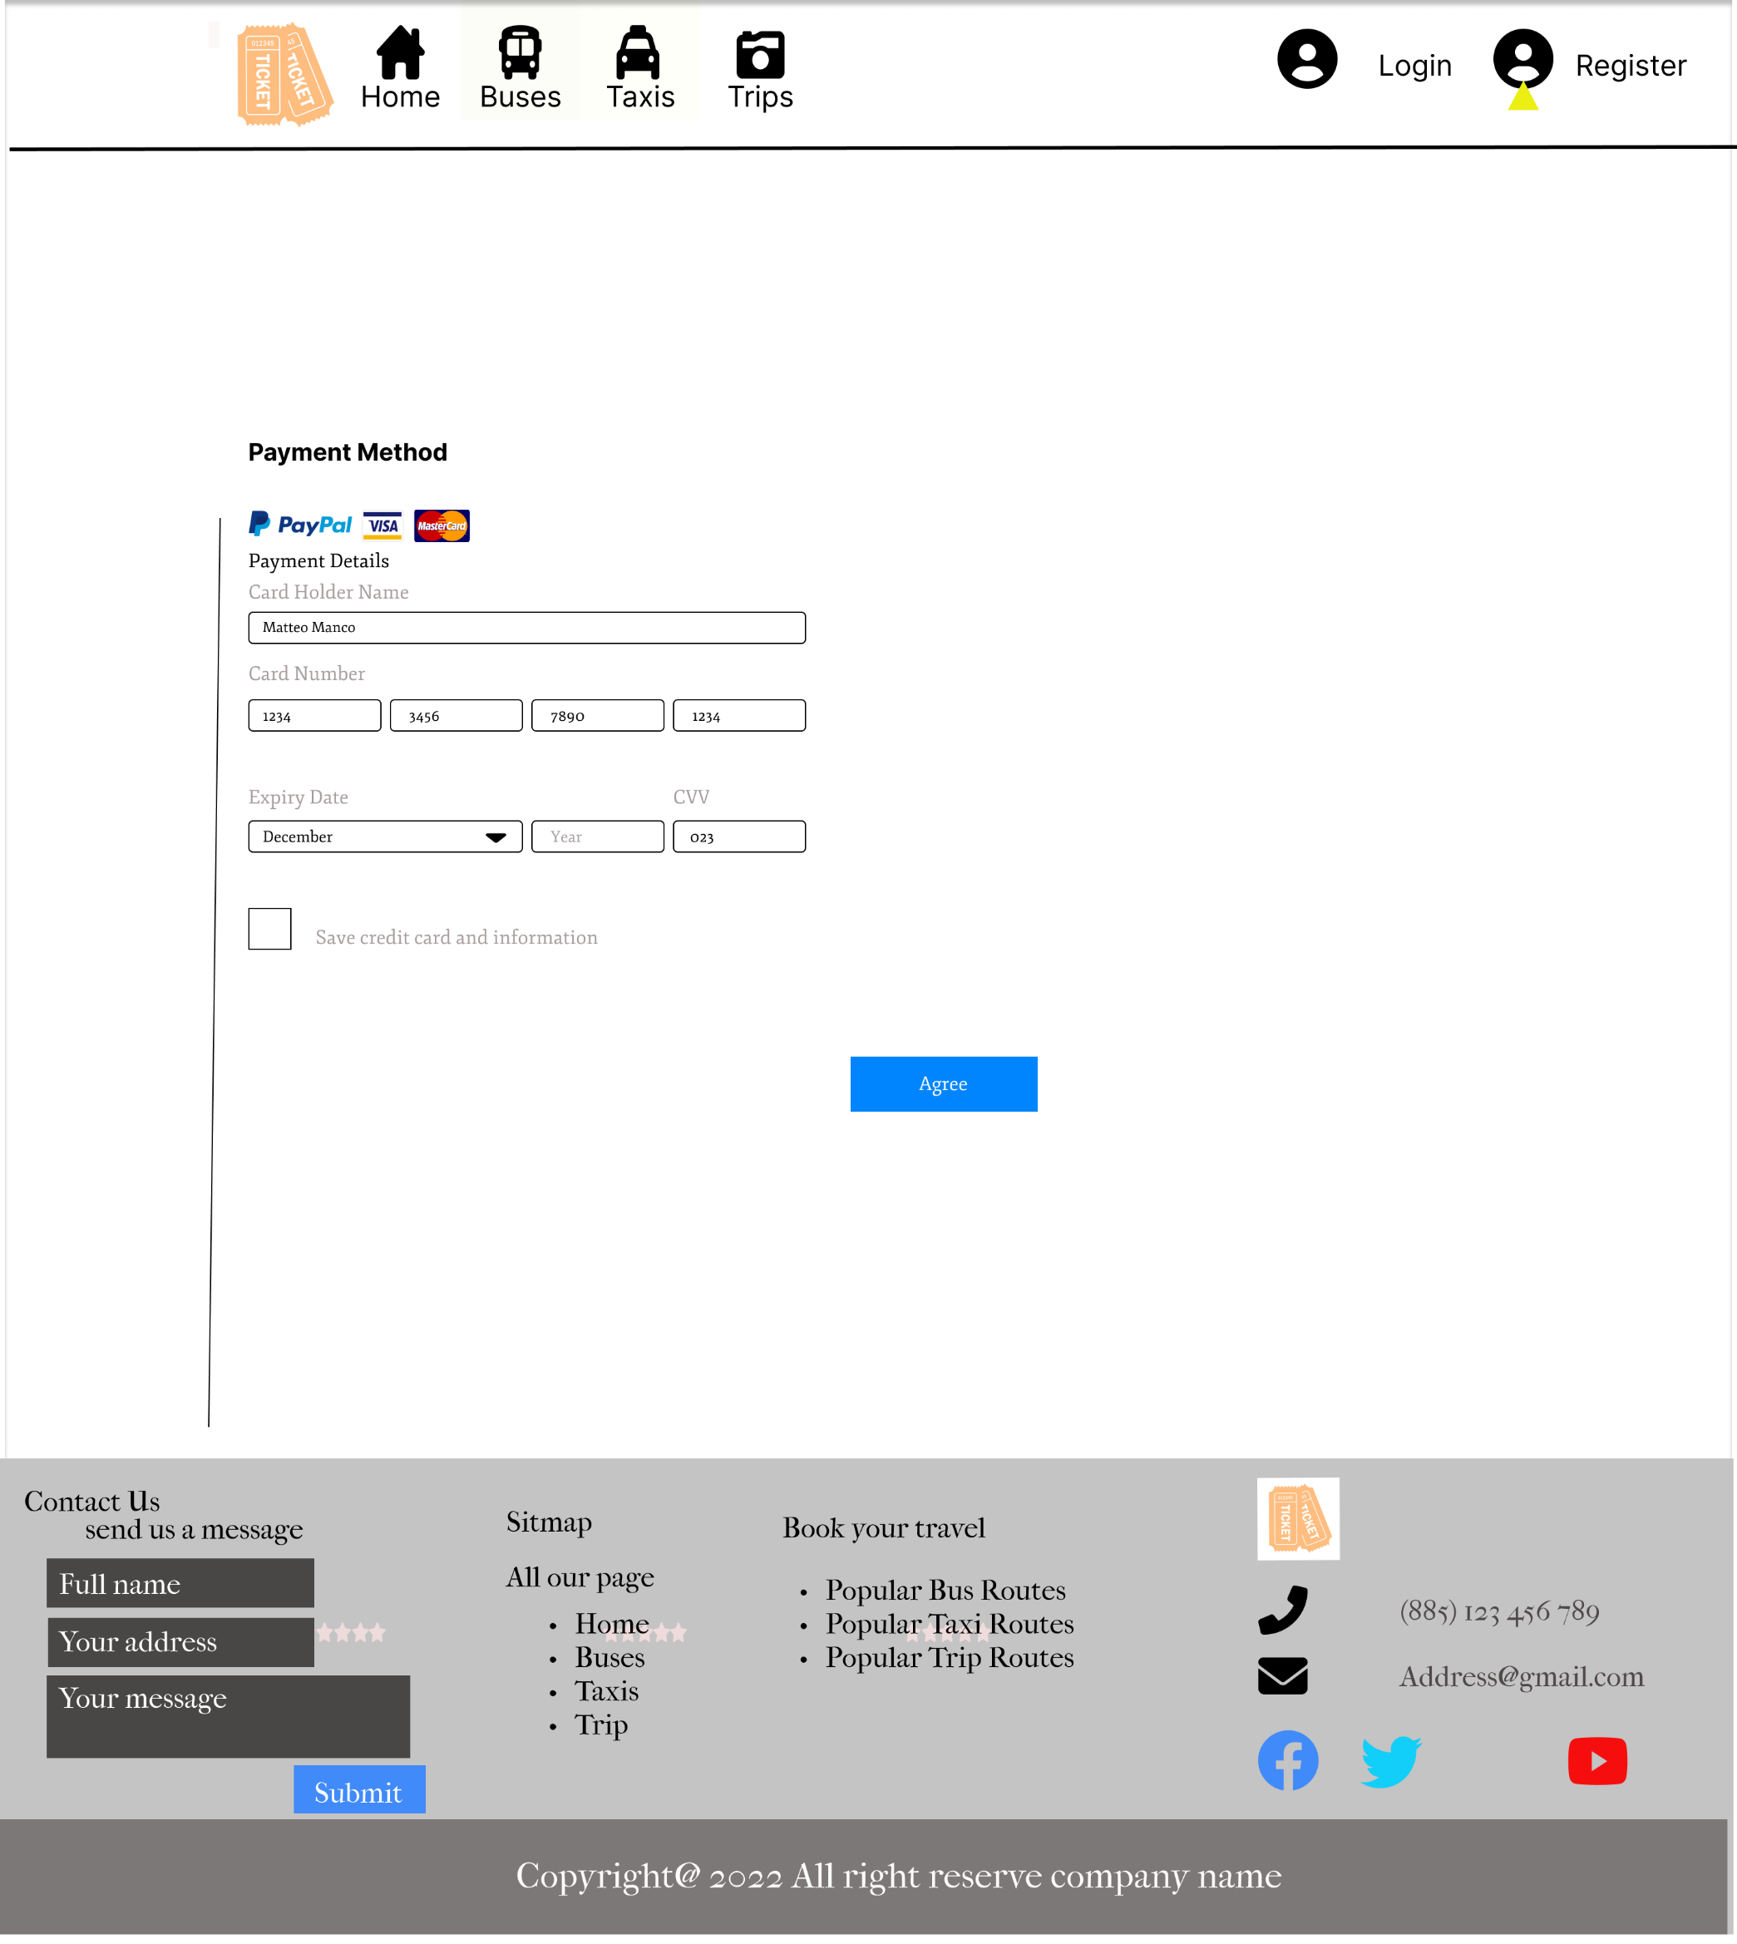

# **Payment Method**

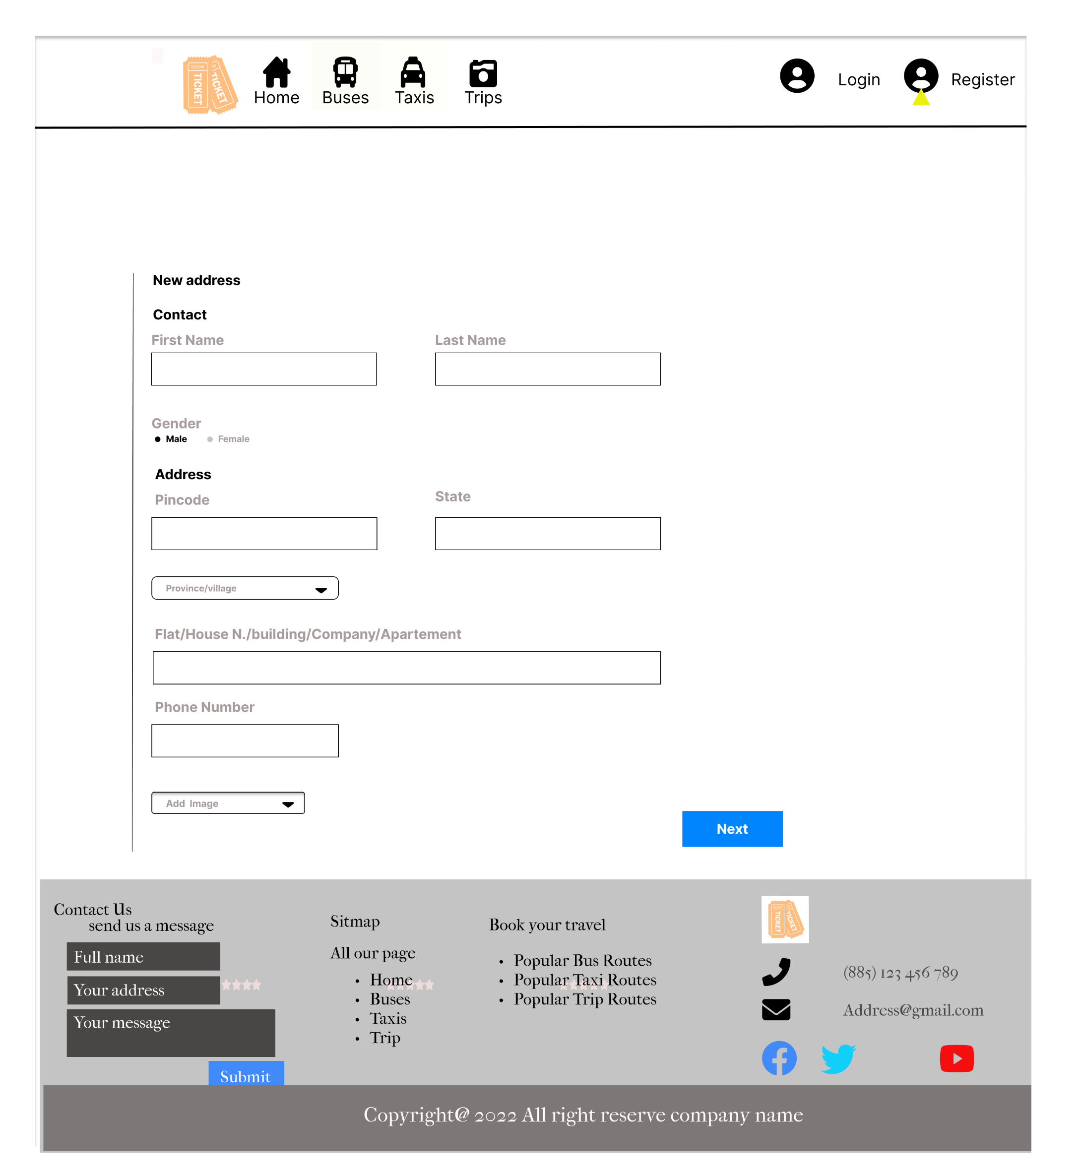

# **Payment Method (form filling)**

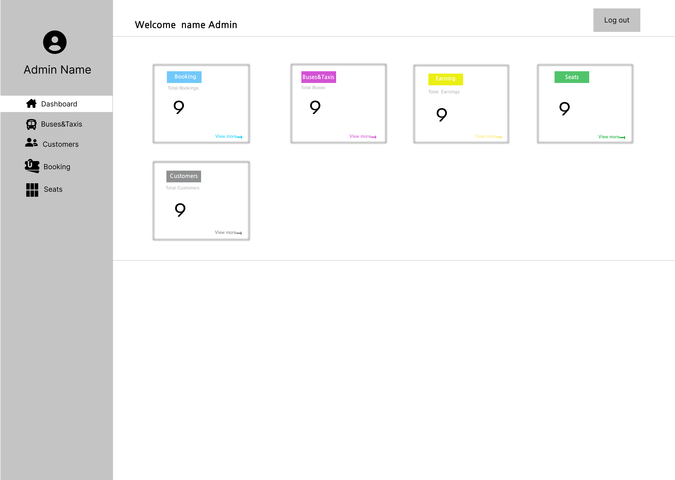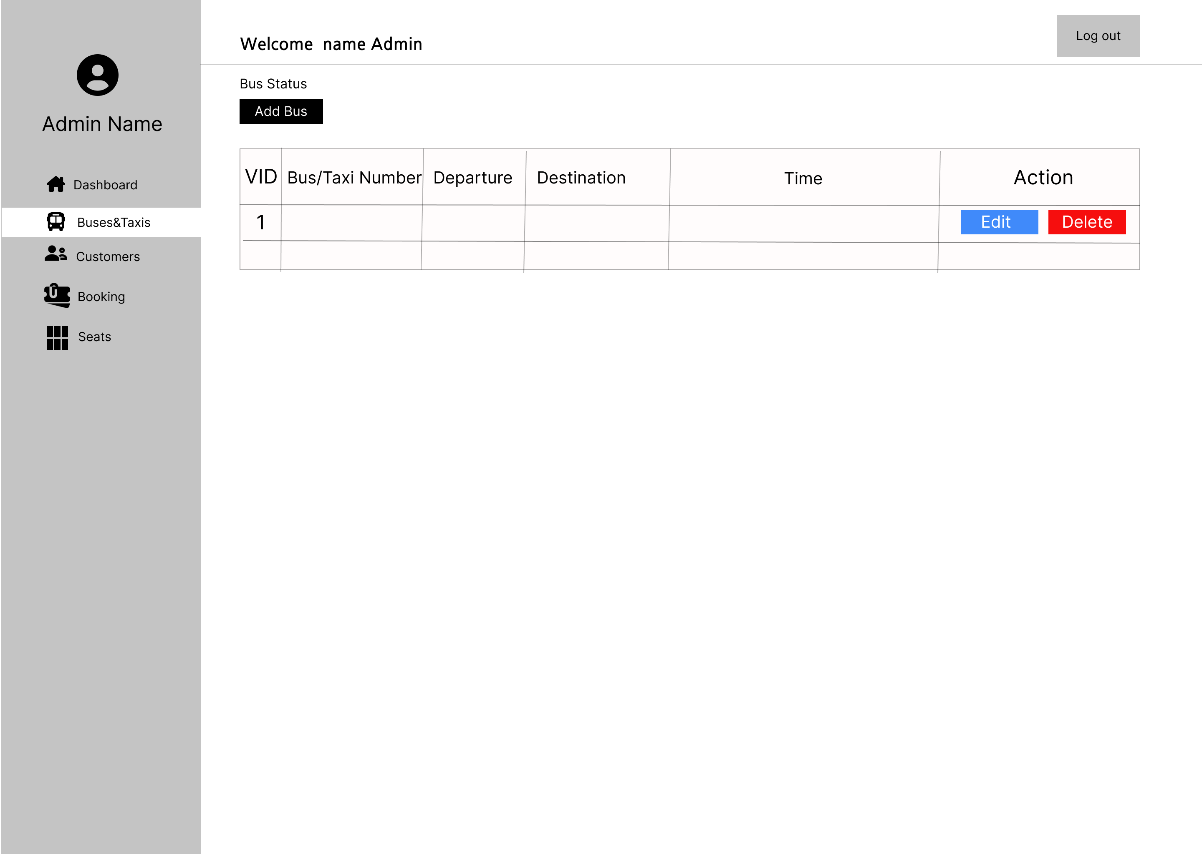

# **Admin**

# **Bus Taxi**

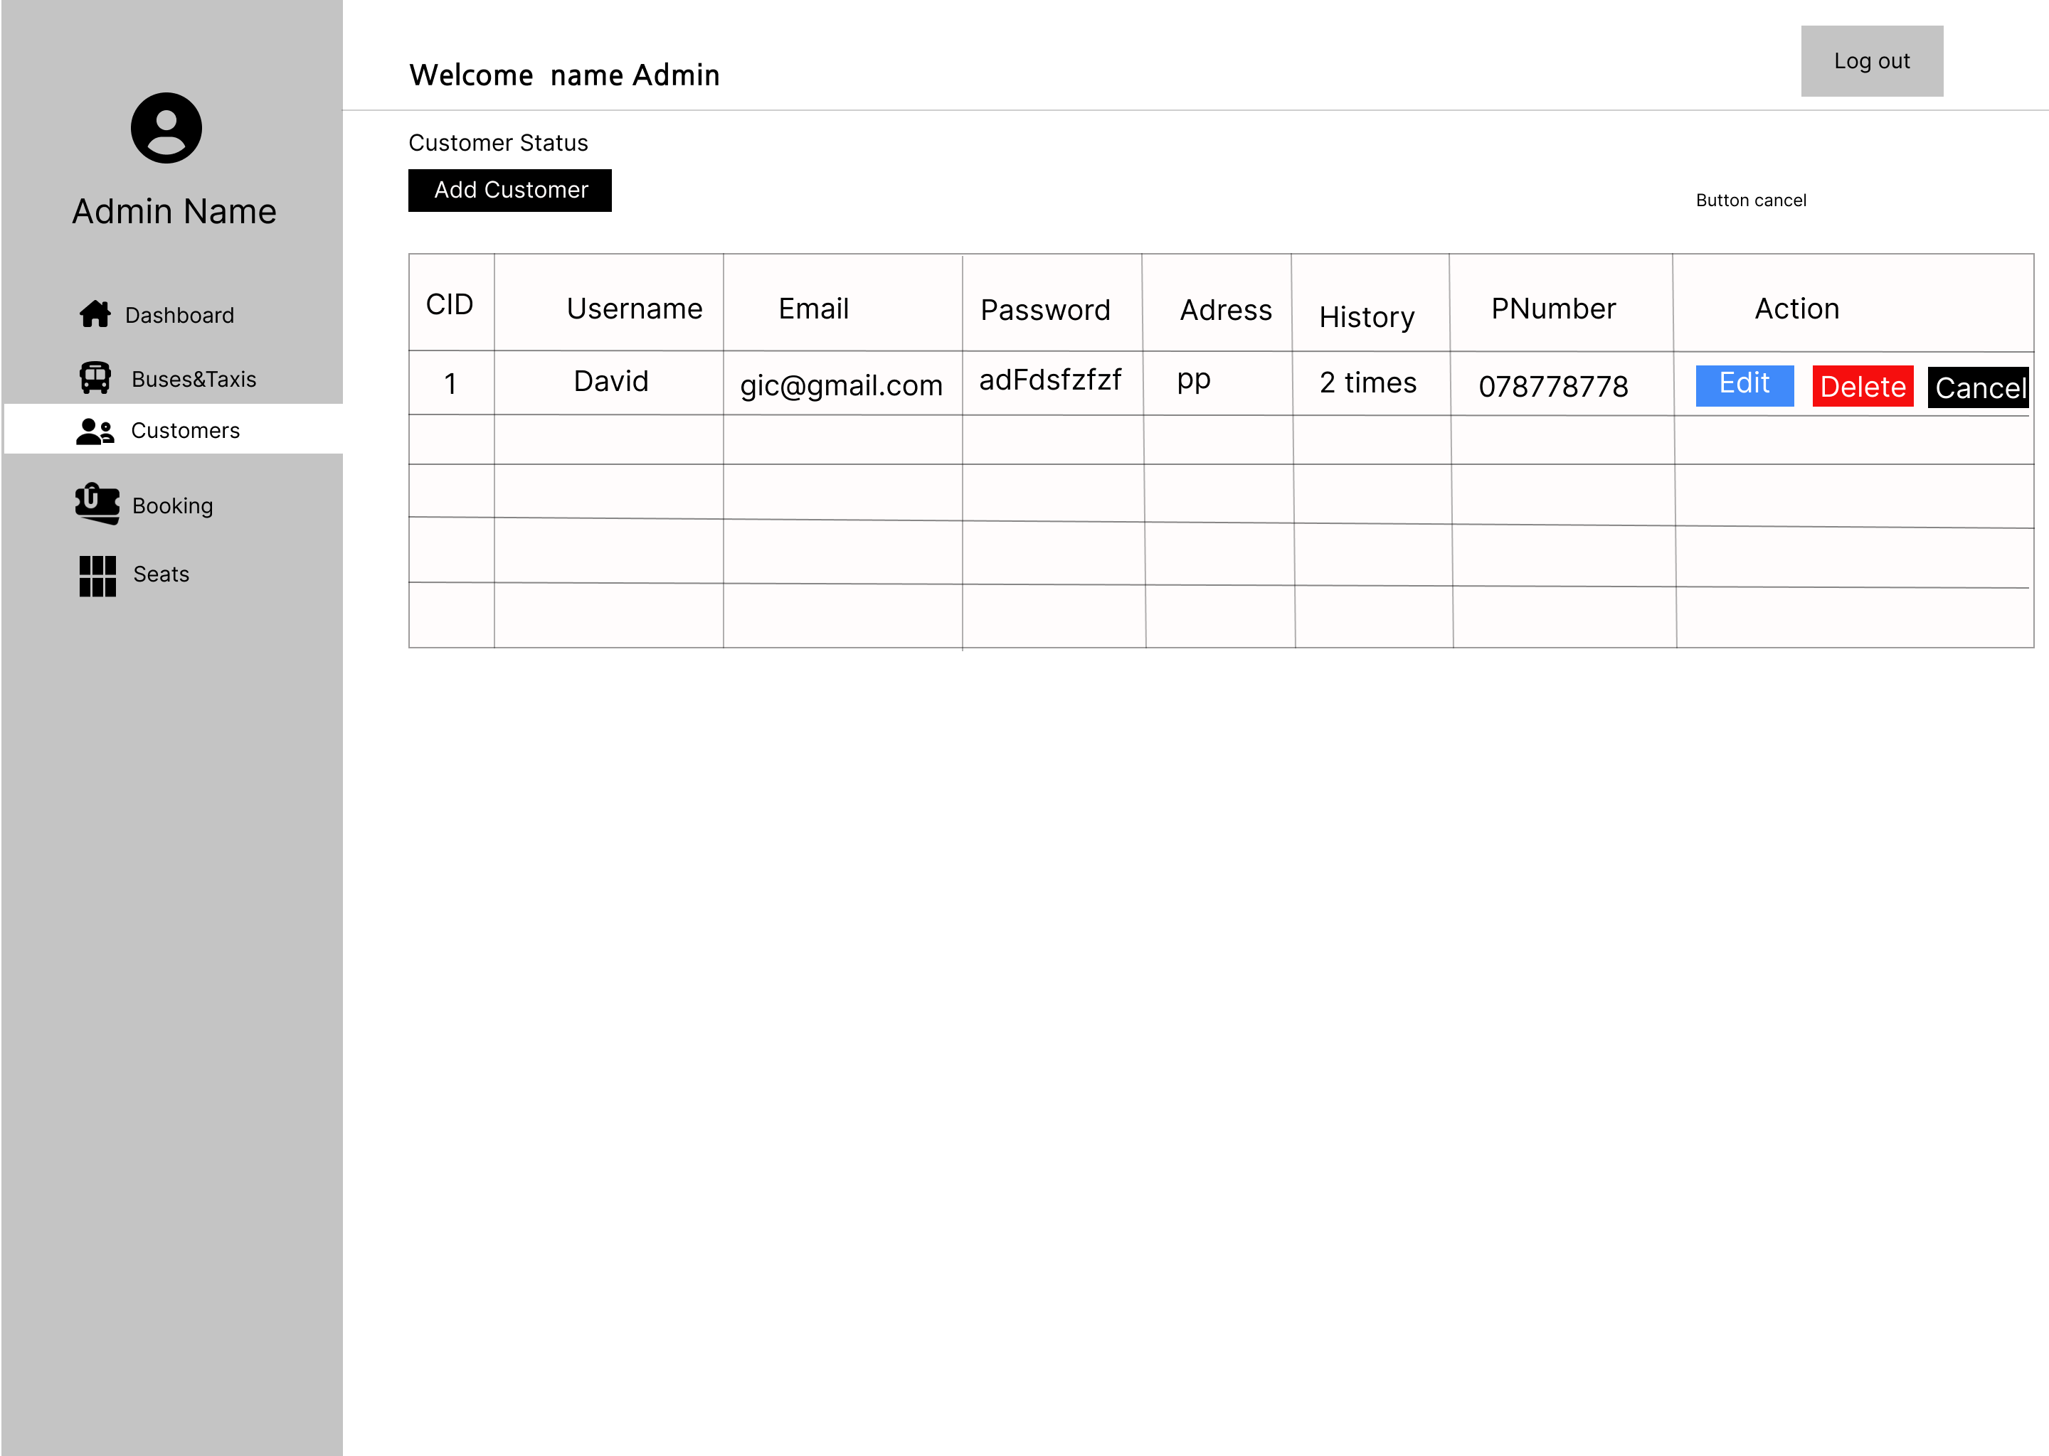

# **Customer**

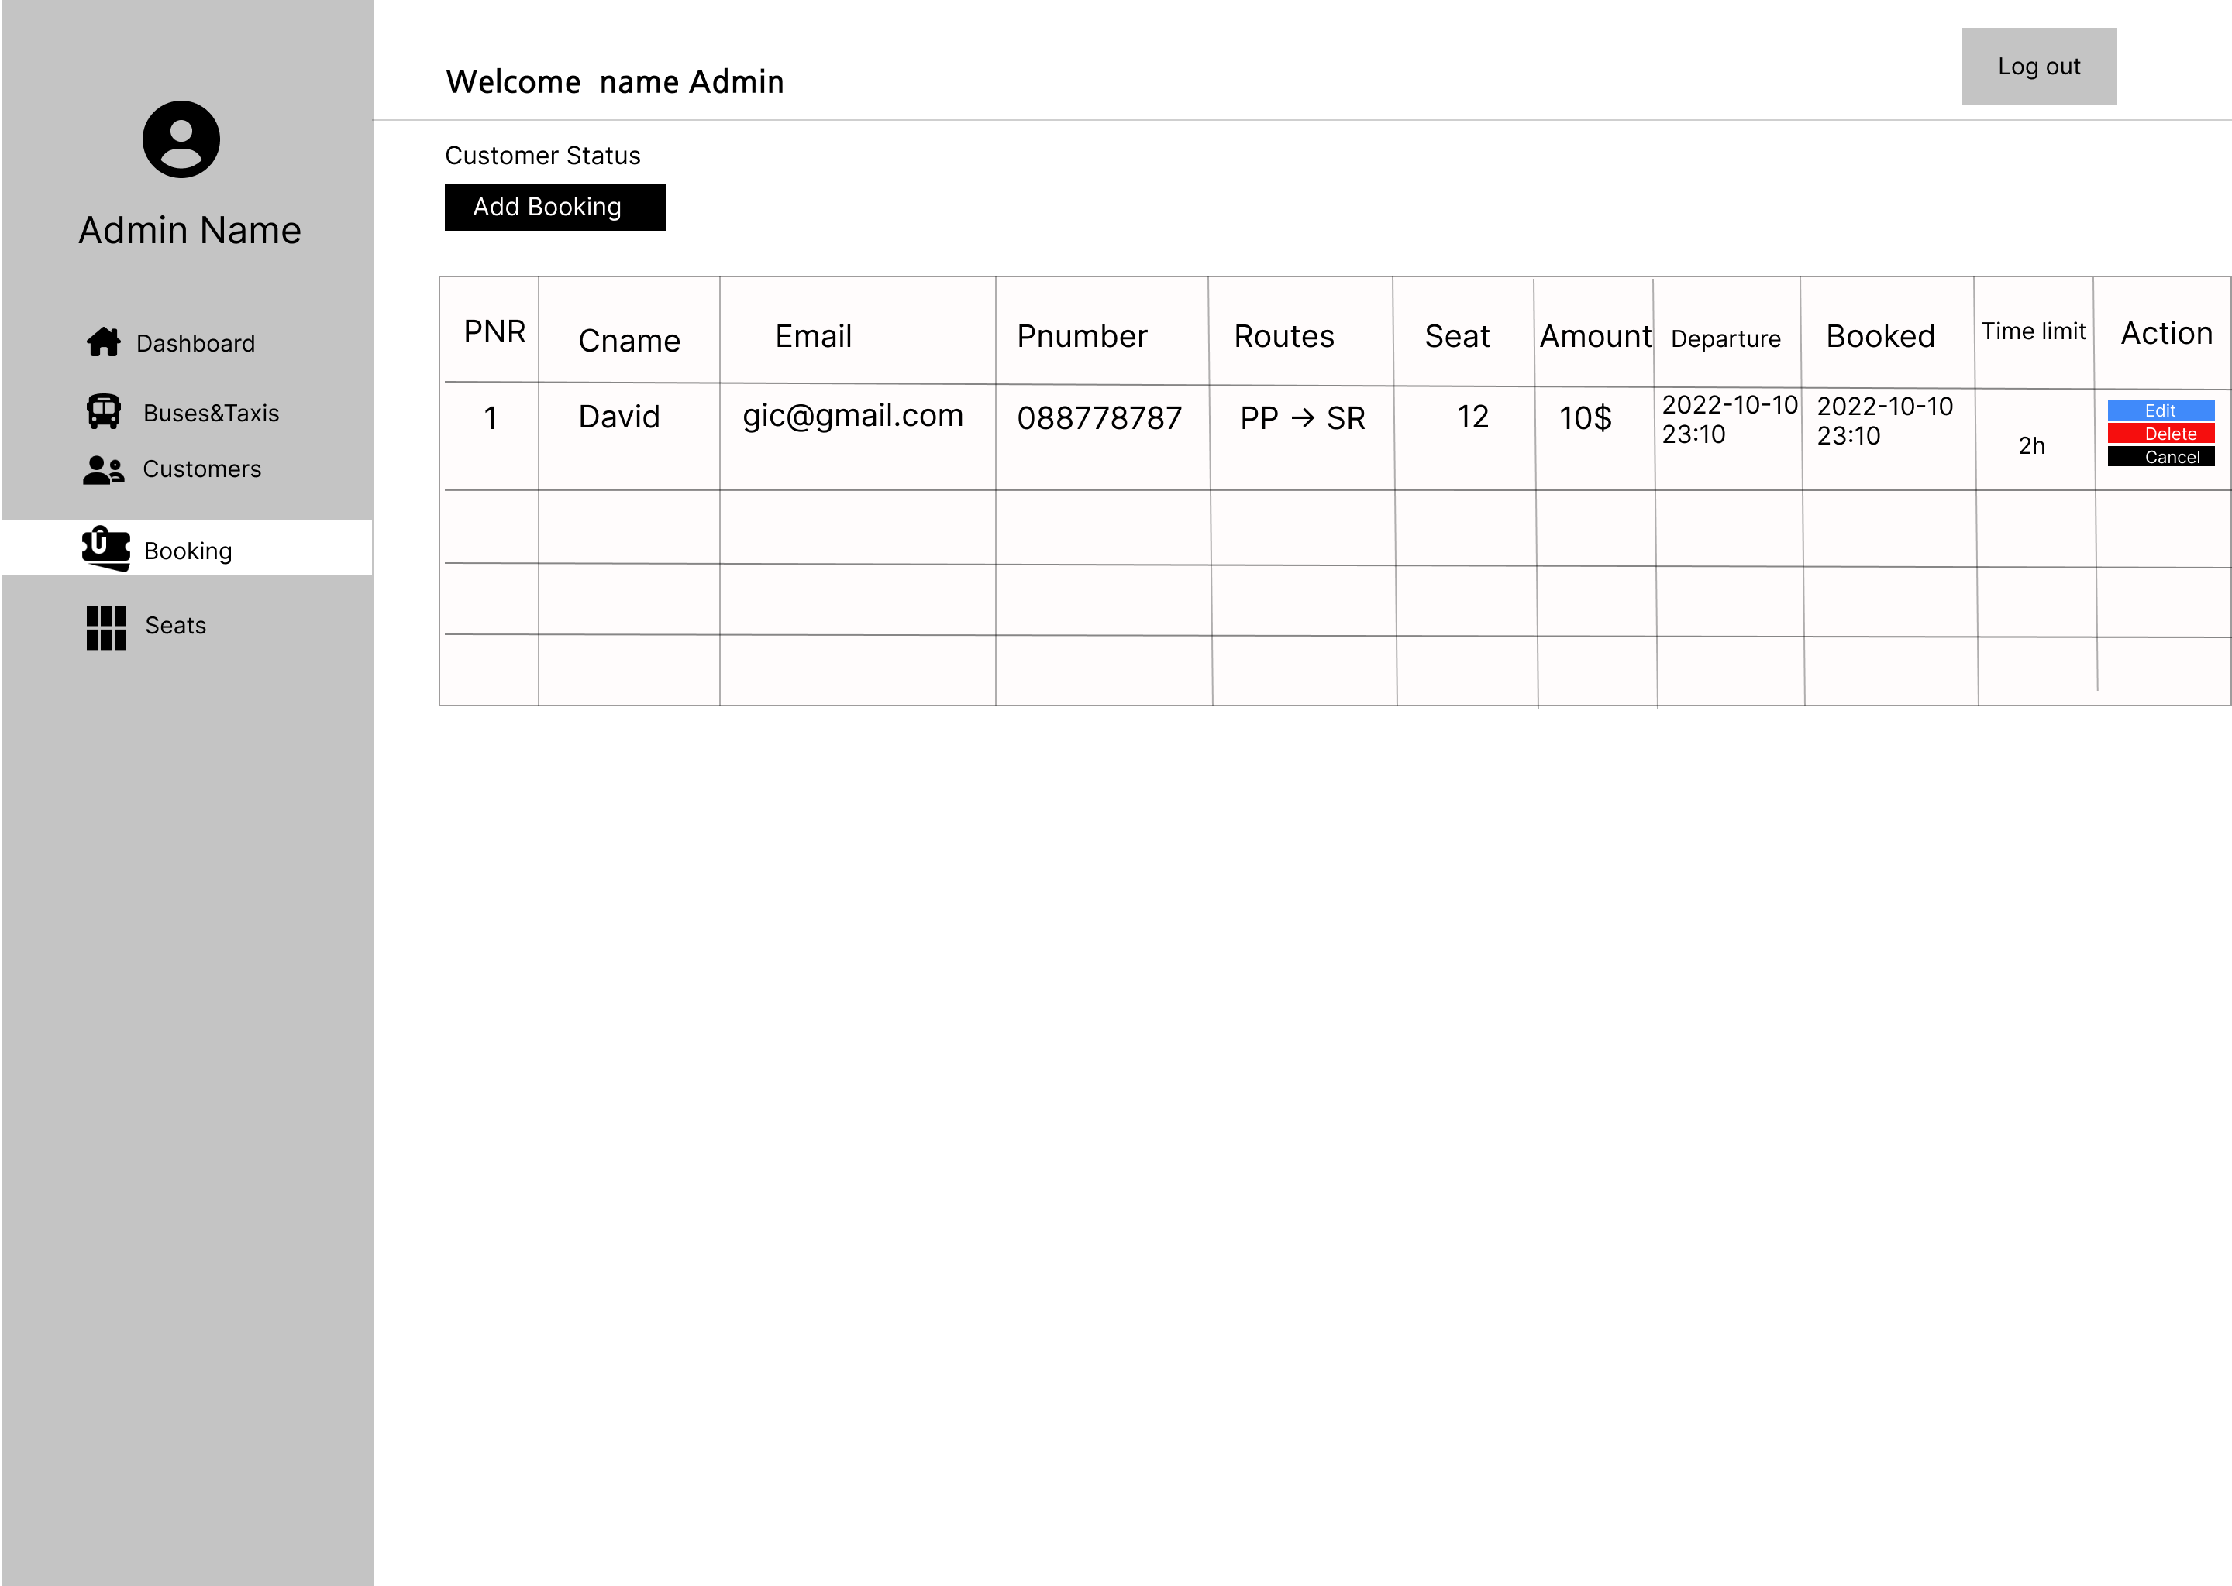

# **Booking**

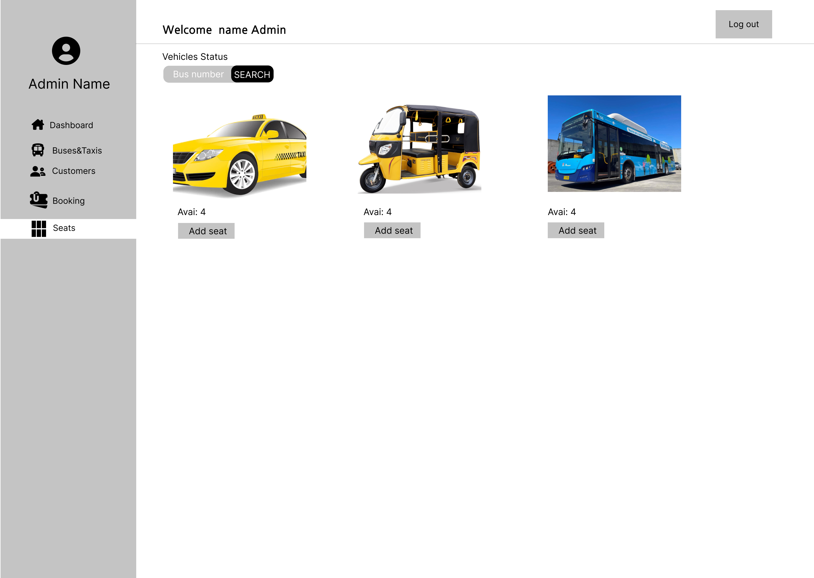

# **Seat**

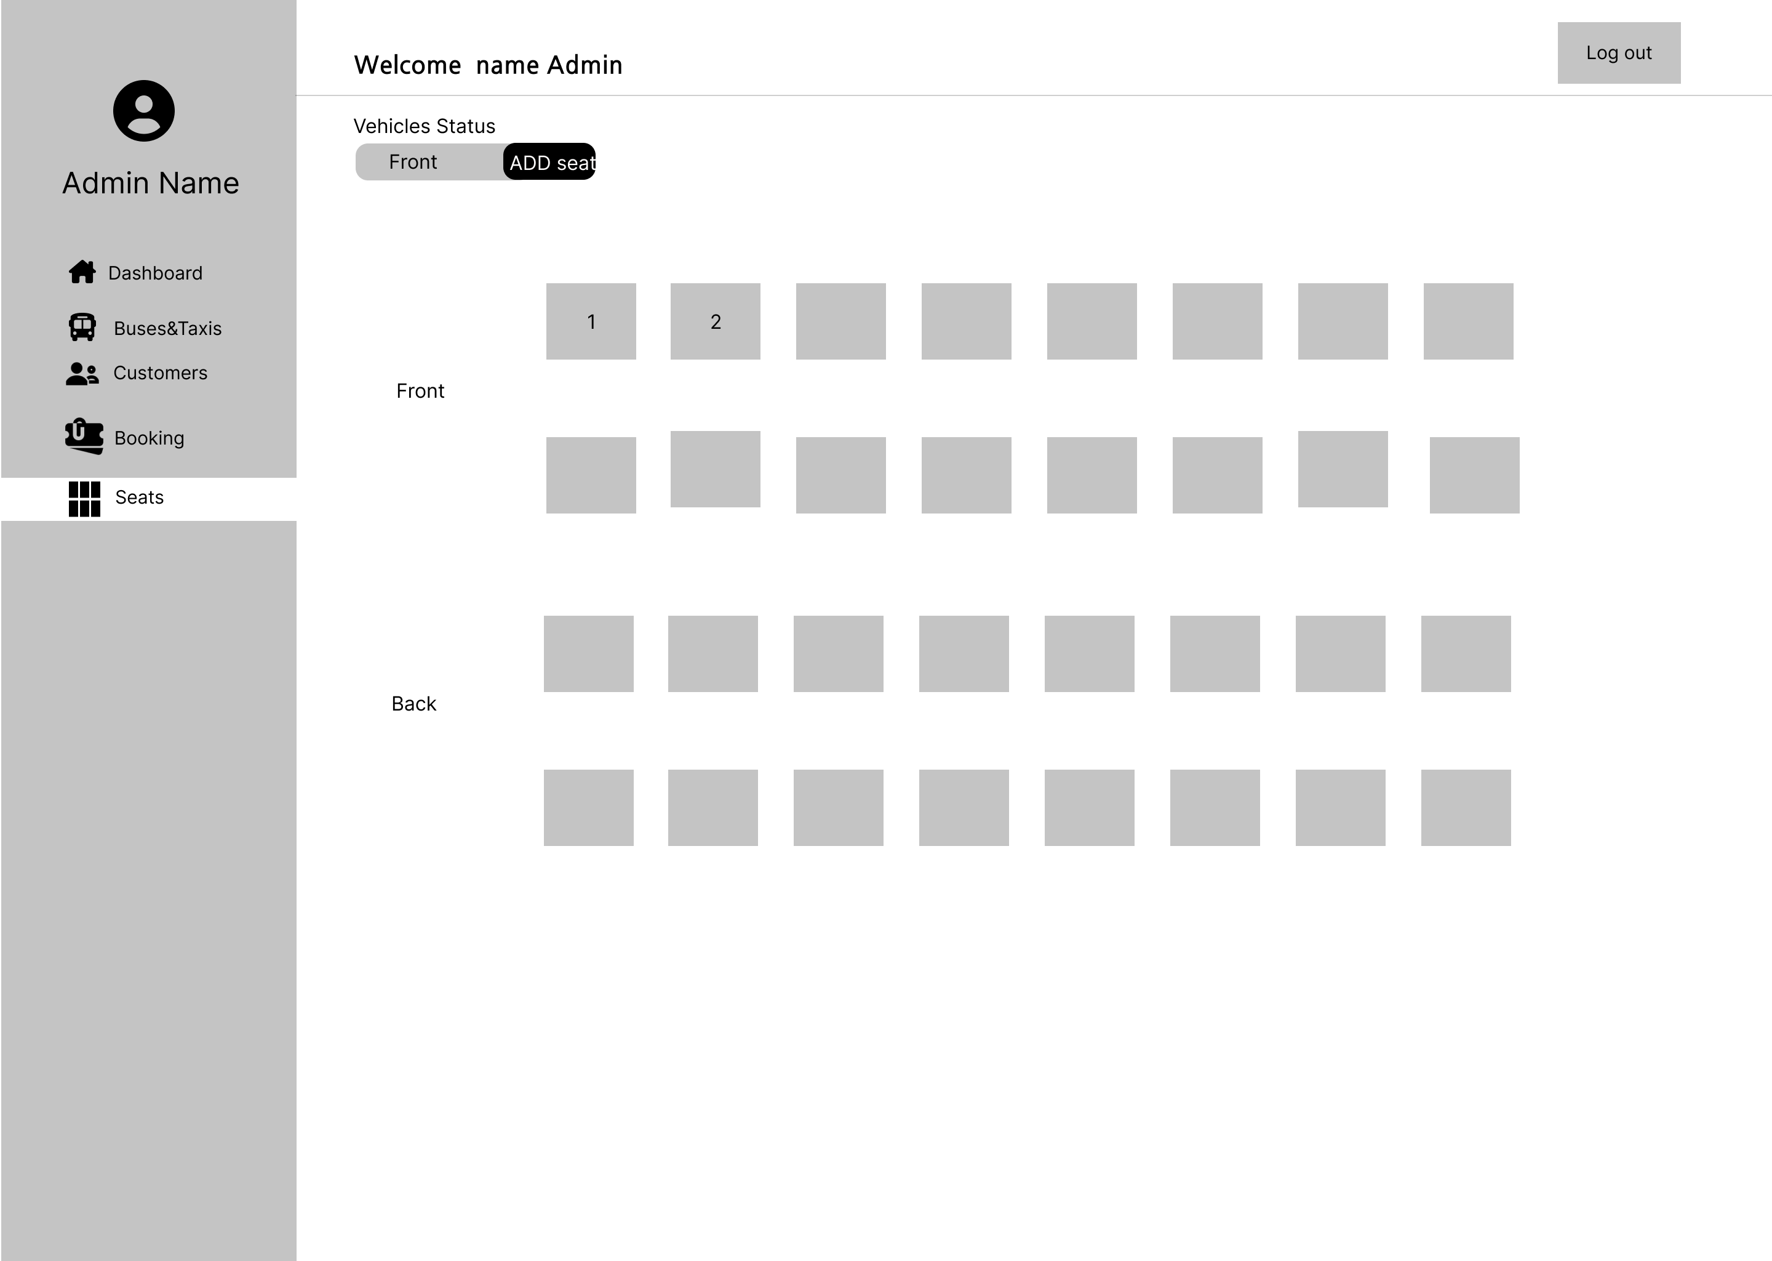

# **Seat**

# **OUR UML DIAGRAM**

# **Activities Diagram**

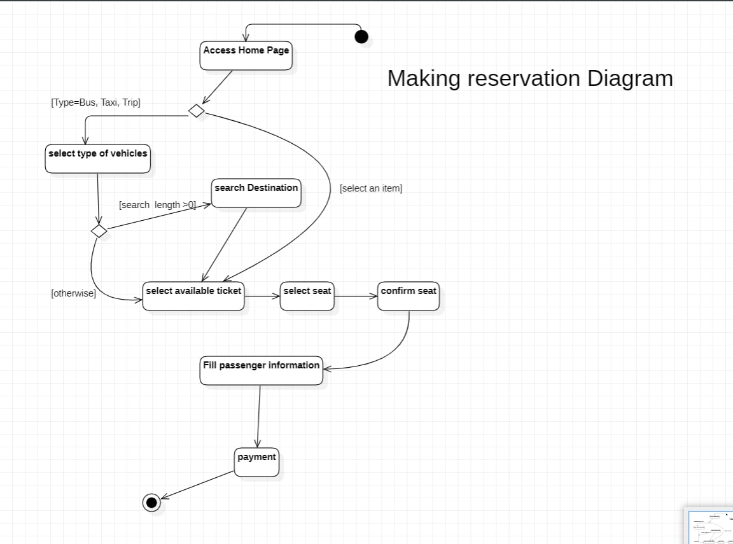

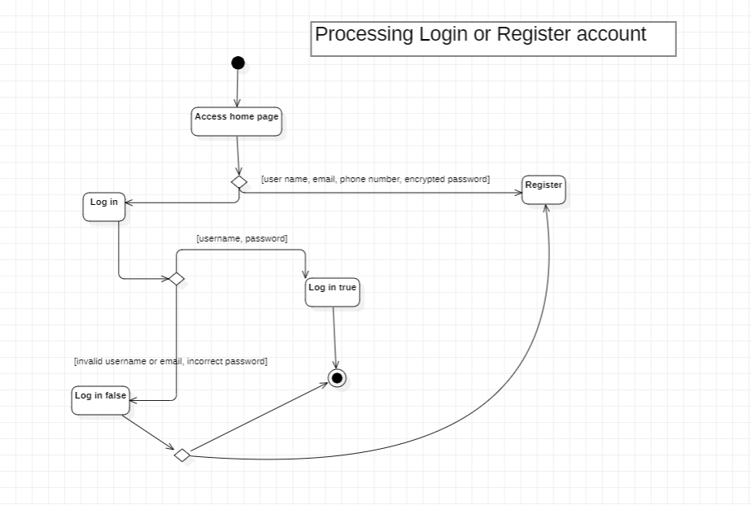

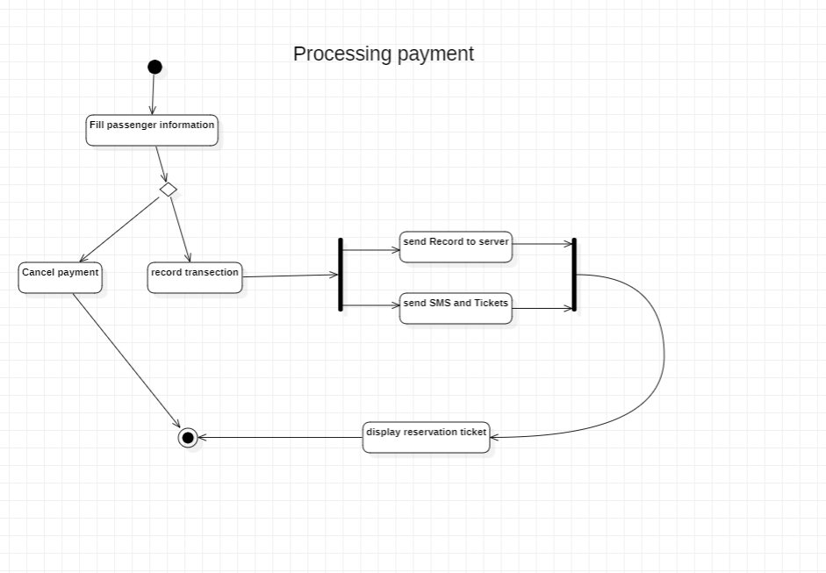

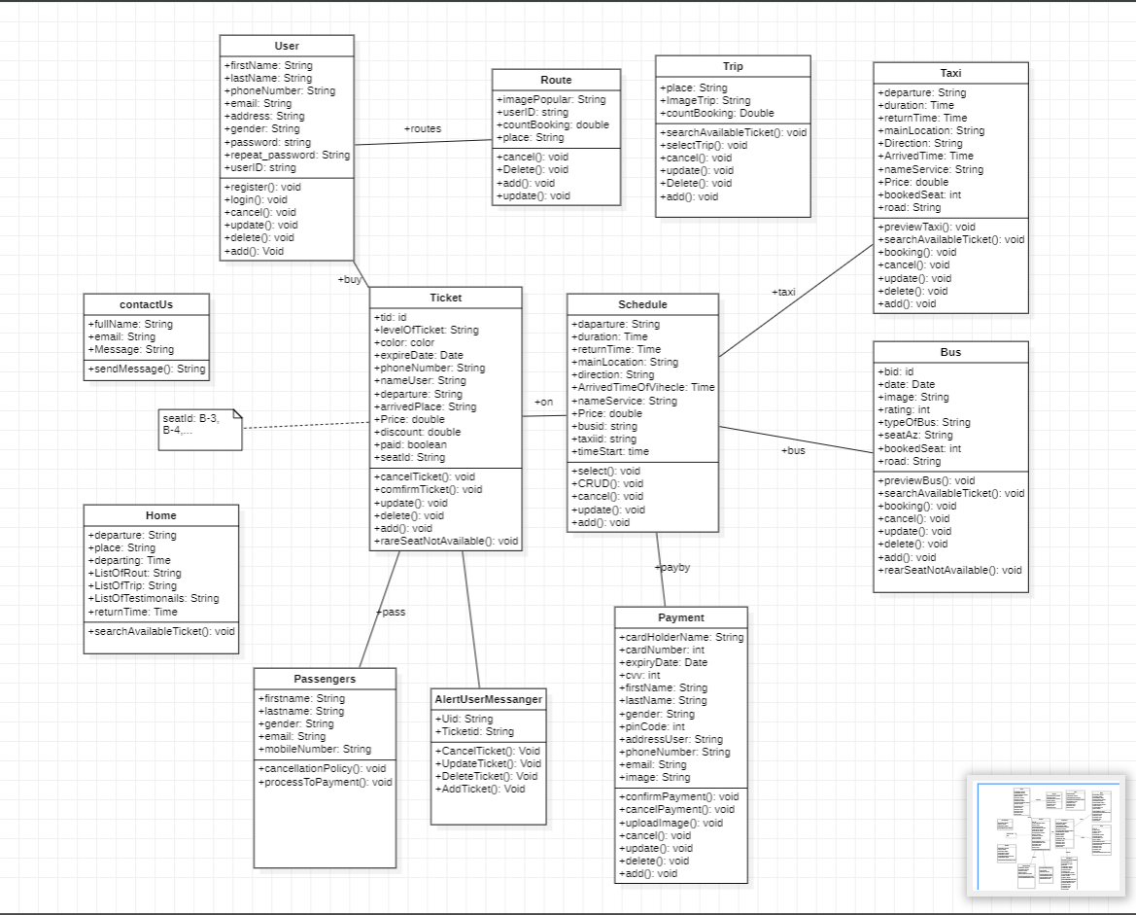

# **Class Diagram**

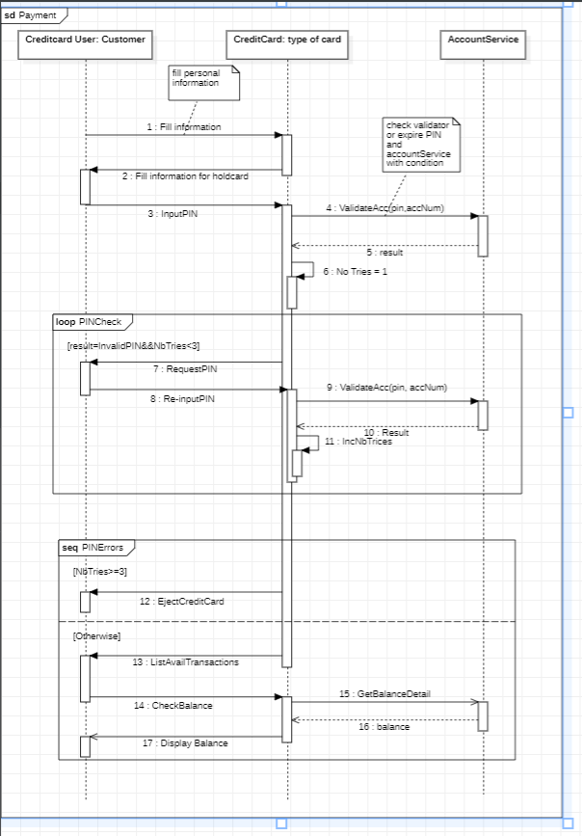Sequence Diagram

* Payment

* 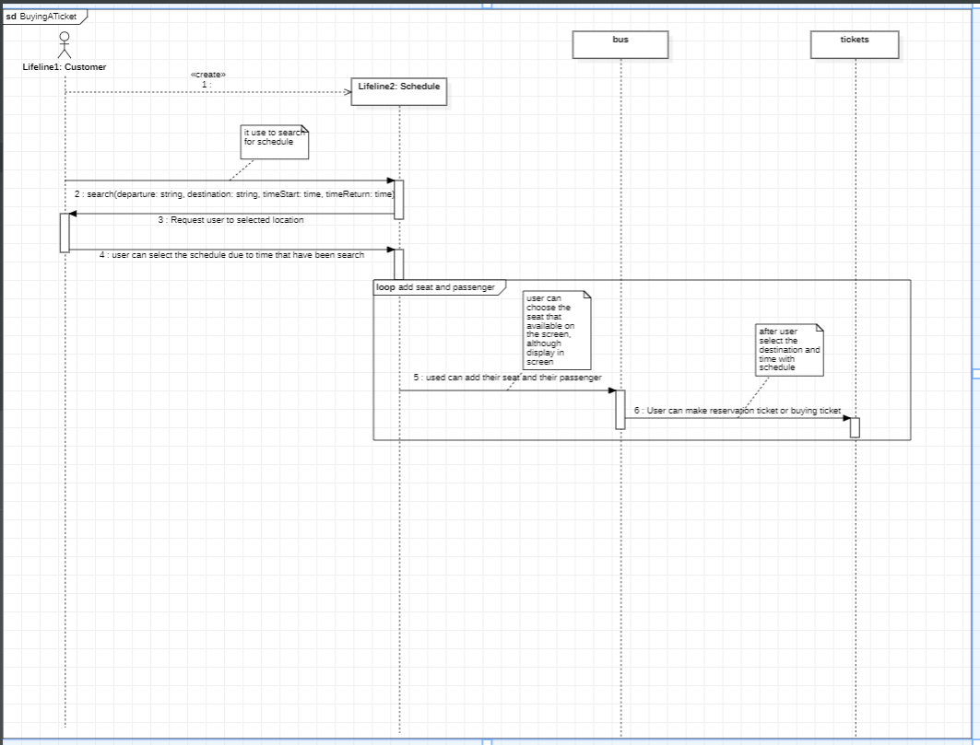 Buying

Ticket